Dondossola et al.:
Procurement and Ex-situ Perfusion of Isolated Slaughterhouse-Derived Livers as a Model of Donors after Circulatory Death

Supplementary Data

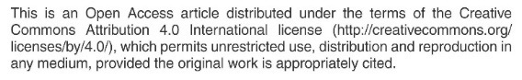
Tab. S1: Instruments and materials employed during procurement and perfusion
Instruments | Manufacturer
Slaughterhouse procurement
7.0 Endotracheal Tube | Unomedical, Malaysia
Ambu Bag | General Electrics, USA
Surgical instruments
Organ bags | Delta Med, Italy
Parenteral nutrition bags | Fresenius-Kabi, Germany
Blood bags | Macropharma, France
Organ transport box | IGL, France
12 and 14 CH, Foley Catheter | Rüsch, Teleflex, USA
Urological set | Ferrari, Italy
0 and 4-0 Vicryl tie | Ethicon, Sweden
0, 3-0, 5-0 Prolene suture | Ethicon, Sweden
NMP circuit
Vigilance, cardiac monitor | Edwards Lifescience, USA
Organ Chamber | Custom made
7 Fr 3-way ARROW CVC | Teleflex, USA
Centrifugal pump, Biomedicus | Medtronic, USA
Membrane lung Quadrox ID Pediatric | Maquet, Germany
Hepatic artery Cannula, 14-16 Fr | Edwards, USA
Portal vein Cannula, 28 Fr | Edwards, USA
Temperature probe | Philips, Netherland
40 micron filter | Haemonetics, USA
Heparin-Coated Polyvinyl Tubing | Dideco-Sorin, Italy
Blood Gas Analyzser, ABL 800 Flex | Radiometer Medical ApS, Denmark
Precision Scale, PT150 | Sartorius AG, Germany
Oven Swallow fan incubator | LT Scientific, UK
Heat Exchanger, Medi-Therm II | Gaymar Industries Inc, USA

Tab. S2: Fluids, chemicals and drugs employed during procurement and perfusion
Drugs | Manufacturer
Slaughterhouse procurement
Sodium citrate 99.9% | Sigma-Aldrich, Germany
Sodium heparin 300 IU/kg | Farmaceutici caber S.p.A, Italy
Ceftriaxone, 1 g | Mylan, USA
Dialysis solution, 5 L
Celsior solution, 1 L | IGL, France
NMP perfusate composition
Homologus concentrated red blood cells
Gelofusine, 500 mL | B. Braun, Italy
Clinimix N14G30 | Baxter, Italy
Human albumin 200g/L | Kedrion, Italy
NaHCO₃ 8.4% 10 mg | S.A.L.F. S.p.A., Italy
CaCl₂, 1.36 mEq/mL 0,6 mg | Bioindustria L.I.M. S.p.A., Italy
Metronidazole, 500 mg | Sandoz, Germany
Ceftriaxone, 1 g | Mylan, USA
Sodium heparin 300 IU/kg | Farmaceutici caber S.p.A, Italy
Cernevit | Baxter, Italy
Actrapid, 100 IU/mL | Novo Nordsik, Danmark
Sterile H₂O, 10 mL | S.A.L.F. Italy
Ringer lactate, 500 mL | Fresenius Kabi, Germany

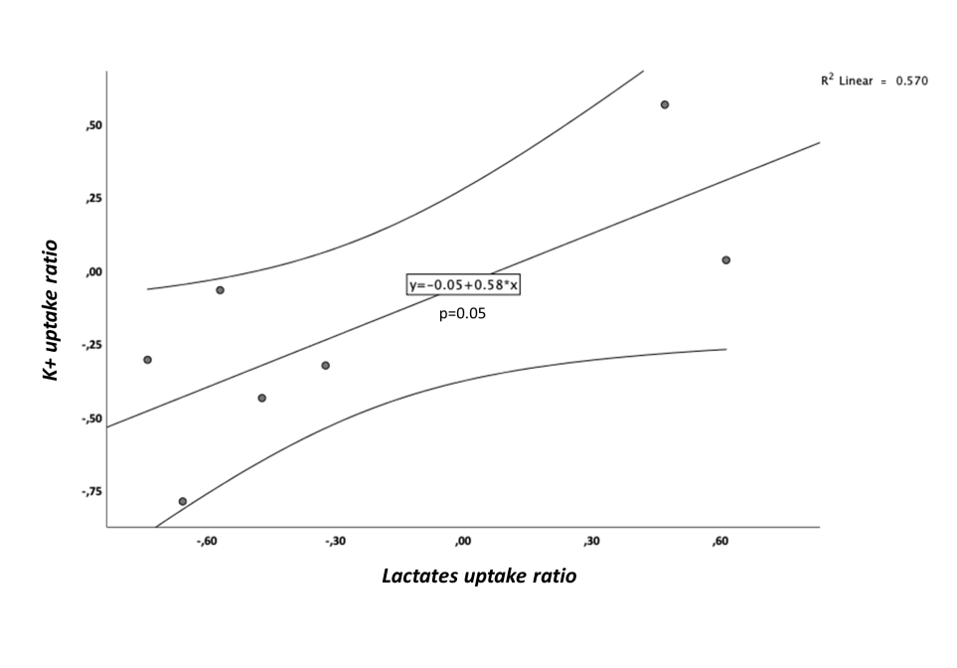

Fig. S1: Linear regression of lactates and potassium release ratio

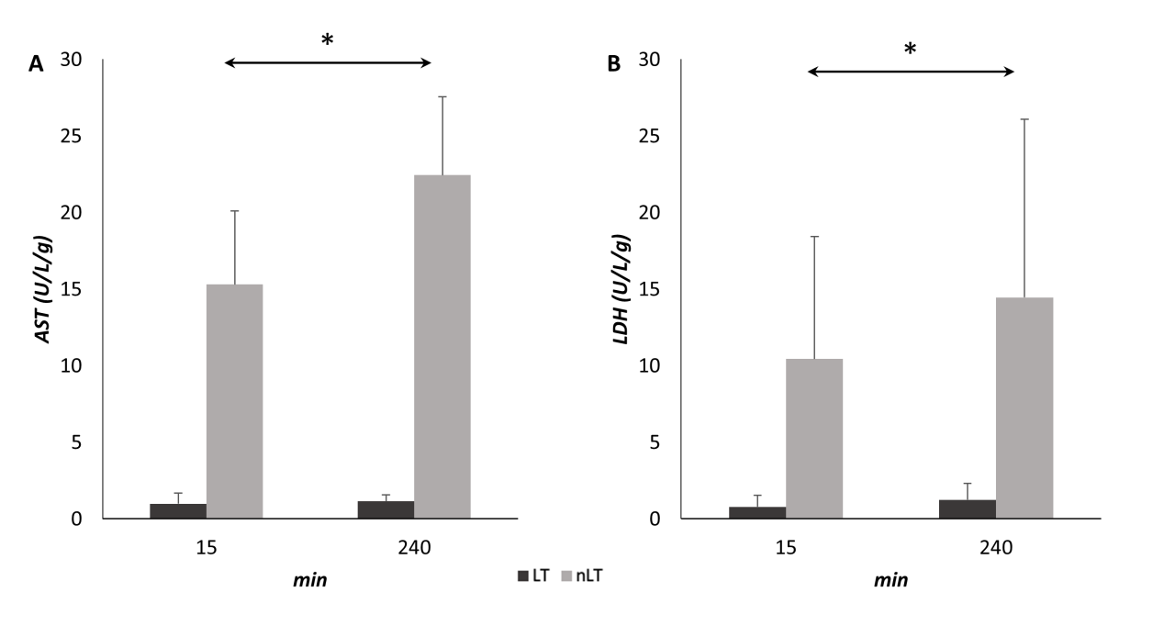
Fig. S2: Hepatocellular damage markers during normothermic machine perfusion
(A) Postoperative AST levels in nLT-G and LT-G. (B) Lactate dehydrogenase (LDH) levels in nLT-G and LT-G. Data expressed as mean ±SEM (*, p < 0.001 by repeated measures analyses).
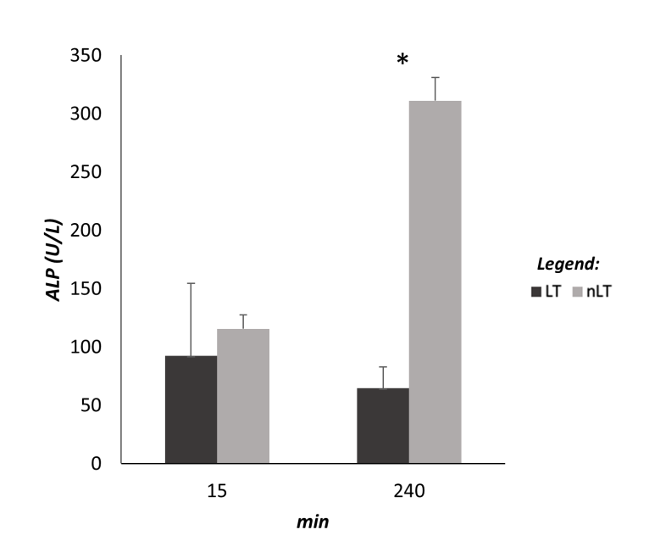
Fig. S3: Cholangiocellular damage (ALP) during normothermic machine perfusion in the two study groups
Data expressed as mean ±SEM (*, p = 0.001 by repeated measures analyses).

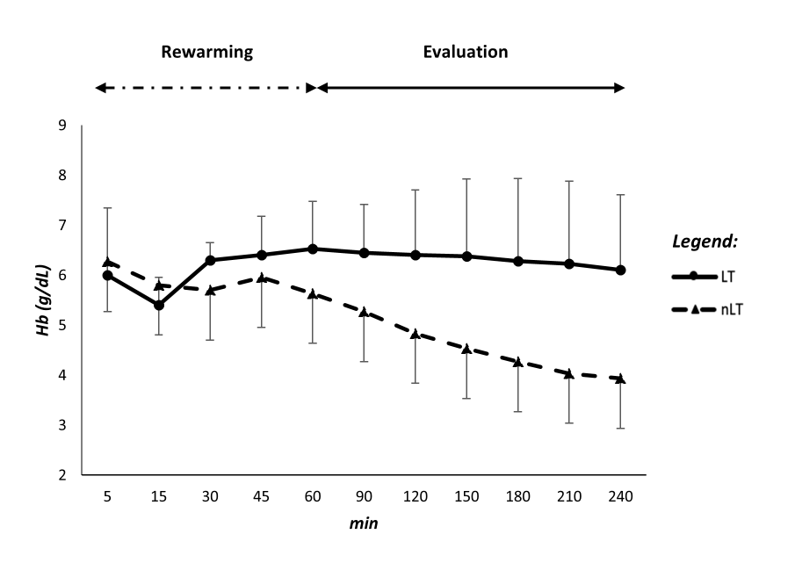
Fig. S4: Hemoglobin trend during normothermic machine perfusion
nLT-G showed hemolysis compared to LT-G. Data expressed as mean ±SEM (*, p = 0.009 by repeated measures analyses).

doi:10.14573/altex.1909131s

